

DEPARTMENT OF INFORMATION SCIENCE & ENGINEERING
Emotion Companion: Personalized Real-Time Emotion Recognition and Adaptive Interaction System

Submitted to
RAMAIAH INSTITUTE OF TECHNOLOGY
Bengaluru, Karnataka

Mini Project Report (ISP67)

Submitted by

Shreyas S G: 1MS23IS118
Susheel Kumar: 1MS23IS132
Thilak M: 1MS23IS134
Varun R: 1MS23IS141

Bachelor of Engineering in Information Science & Engineering

Under the guidance of
J R Shruti
Assistant Professor
Department of Information Science and Engineering
Ramaiah Institute of Technology

DEPARTMENT OF INFORMATION SCIENCE & ENGINEERING
RAMAIAH INSTITUTE OF TECHNOLOGY
(Autonomous Institute, Affiliated to VTU)

DEPARTMENT OF INFORMATION SCIENCE AND ENGINEERING
RAMAIAH INSTITUTE OF TECHNOLOGY
BANGALORE-54

CERTIFICATE
This is to certify that the project work titled E-MOTION COMPANION: Personalized Real-Time Emotion Recognition and Adaptive Interaction System is a bonafide work carried out by Shreyas S G (1MS23IS118), Susheel Kumar Naik (1MS23IS132), Thilak M (1MS23IS134), and Varun R (1MS23IS141) in partial fulfillment for the course of Bachelor of Engineering in Information Science and Engineering during the year 2026. The Project report has been approved as it satisfies the academic requirements with respect to the project work. To the best of our understanding the work submitted in this report has not been submitted anywhere.

Signature of the Guide Signature of the HOD



DECLARATION

We hereby declare that the mini project entitled “Emotion Companion: Personalized Real-Time Emotion Recognition and Adaptive Interaction System” has been carried out by us at Ramaiah Institute of Technology under the guidance of J R Shruti, Assistant Professor, Department of Information Science and Engineering.
We further declare that this work has not been submitted either in part or in full for the award of any degree, diploma, or other academic qualification in this or any other institution.

Shreyas S G 1MS23IS118
Susheel Kumar 1MS23IS132
Thilak M 1MS23IS134
Varun R 1MS23IS141

Place: Bengaluru
Date: 20-05-2026

ABSTRACT

Facial Emotion Recognition (FER) plays an important role in human-computer interaction, healthcare, surveillance, and intelligent assistant systems. Traditional FER systems mainly focus on frame-by-frame emotion classification and often fail to consider temporal emotional behaviour and individual facial expression differences. This project proposes an Emotion Companion: Personalized Real-Time Emotion Recognition and Adaptive Interaction System that combines deep learning, temporal stabilization, and personalized emotion calibration for improved real-time emotion recognition.
The proposed system uses OpenCV Haar Cascade for real-time face detection and preprocessing, while ConvNeXt-Tiny, a modern convolutional neural network architecture, is employed for extracting discriminative facial features and classifying emotions. The model is trained using the FER-2013 dataset and integrated with a real-time webcam-based prediction pipeline. To improve prediction consistency, temporal probability smoothing using a rolling 5-frame probability buffer.
Additionally, a personalized baseline emotion calibration mechanism is introduced to interpret emotions relative to a user’s natural facial expression patterns, thereby reducing false classifications and improving personalization. The system is integrated with a React-based dashboard that provides live emotion visualization, analytics, session tracking, and emotion-aware music recommendations.
The developed ConvNeXt-Tiny model achieved an overall test accuracy of approximately 74.2% on the FER-2013 dataset while maintaining stable and adaptive real-time emotion recognition performance. The proposed framework enhances the reliability of emotion recognition systems by combining advanced deep feature extraction, temporal stabilization, and personalized emotional calibration, making it suitable for intelligent human-centric AI applications.

ACKNOWLEDGEMENT

We would like to express our sincere gratitude to all those who supported us in completing this mini project successfully.
We are thankful to the Management and the Principal Dr. N.V.R Naidu of Ramaiah Institute of Technology, Bengaluru, for providing us with the opportunity and resources to carry out this work.
We express our heartfelt thanks to Dr. Sumana M, Head of the Department, Department of Information Science and Engineering, for the constant encouragement and guidance throughout the project.
We are especially grateful to our project guide J R Shruti, for the valuable guidance, suggestions, and continuous support provided at every stage of the project. Their insights helped us in understanding the concepts clearly and completing the work effectively.

Table of Contents
1.INTRODUCTION 10
1.1 General Introduction 10
1.2 Problem Statement 11
1.3 Objectives of the Project 11
1.4 Project Deliverable 11
1.4.1 Deliverable Development and Review Process 12
1.5 Current Scope 14
1.6 Future Scope 15
2. PROJECT ORGANIZATION 16
2.1 Software Process Model 16
2.2 Roles and Responsibilities 16
2.3 Finance-Budget Estimation 17
2.4 Sustainable Development Goals (SDGs) 17
3. LITERATURE SURVEY 18
3.1 Introduction 18
3.2 Related Works with Citation of References 18
3.3 Conclusion of Survey 20
4. PROJECT MANAGEMENT PLAN 23
4.1 Schedule of the Project 23
4.2 Risk Identification 25
5. SOFTWARE REQUIREMENT SPECIFICATIONS 27
5.1 Functional Requirements 27
5.1.1 User Interface Module 27
5.1.2 Emotion Detection Module 27
5.1.3 Temporal Stabilization Module 27
5.1.4 Music Recommendation Module 27
5.1.5 Analytics and Session Tracking Module 27
5.1.6 Backend API Module 28
5.2 Non-Functional Requirements 28
5.2.1 Performance Requirements 28
5.2.2 Usability Requirements 28
5.2.3 Reliability Requirements 28
5.2.4 Security Requirements 28
5.2.5 Scalability Requirements 29
5.2.6 Software Quality Attributes 29
6. DESIGN AND IMPLEMENTATION 30
6.1 Introduction 30
6.2 Architecture Design 30
6.3 Data Flow Diagram 33
6.4 Tools and Technologies Used 34
6.5 Overall View of Project Implementation 35
6.6 Machine Learning Model Implementation 35
6.6.1 Baseline ResNet50 Model 36
6.6.2 ResNet50V2 Model 36
6.6.3 Progressive Unfreezing ResNet50V2 36
6.6.4 EfficientNet-B0 Model 36
6.6.5 ConvNeXt-Tiny Model (Final Model) 37
6.6.6 Temporal Stabilization 38
6.6.7 Baseline-Aware Emotion Analysis 38
6.7 Information About Implementation of Modules 38
6.7.1 Frontend User Interface Module 38
6.7.2 Webcam Input and Face Detection Module 39
6.7.3 Image Preprocessing Module 39
6.7.4 Emotion Prediction Module 39
6.7.5 Temporal Stabilization Module 39
6.7.6 Music Recommendation Module 39
7.Results and Discussion 40
7.1 Experimental Setup 40
7.2 Evaluation Metrics 40
7.3 Results 44
7.4 Discussion 46
8. TESTING 47
8.1 Introduction 47
8.2 Testing Tools and Environment 47
8.3 Test Cases 48
9.CONCLUSION AND SCOPE FOR FUTURE WORK 50
9.1 Scope for Future Work 50
10. REFERENCES 51

Table of Figures
Figure 1: Gantt Chart for Project Planning ............................................................................. 24

Figure 2: System Architecture ................................................................................................. 31

Figure 3: Data Flow Diagram ................................................................................................. 34

Figure 4: ResNet50 Confusion Matrix .....................................................................................42

Figure 5: ResNet50 Classification Report ................................................................................42

Figure 6: ResNet50V2 Confusion Matrix ................................................................................42

Figure 7: ResNet50V2 Classification Report...........................................................................42

Figure 8: Progressive ResNet50V2 Confusion Matrix.............................................................43

Figure 9: Progressive ResNet50V2 Classification Report........................................................43

Figure 10: EfficientNet-B0 Confusion Matrix..........................................................................43

Figure 11: EfficientNet-B0 Classification Report.....................................................................43

Figure 12: ConvNeXt model Confusion Matrix.......................................................................44

Figure 13: ConvNeXt model Classification Report..................................................................44

Figure 14: DashBoard……….................................................................................................. 45

Figure 15: Profile Section….................................................................................................... 45

Figure 16: Activity Section….................................................................................................. 46

List of Tables
Table 1: Deliverable Development and Review Process ....................................................... 10

Table 2: Roles and Responsibilities ....................................................................................... 16

Table 3: Comparison of Literature on Facial Emotion Recognition ...................................... 20

Table 4: Schedule Plan ........................................................................................................... 23

Table 5: Risk Identification and Mitigation ........................................................................... 25

Table 6: Comparative Performance Analysis of Evaluated Deep Learning Models...…….....41

Table 7: Testing Environment ................................................................................................ 47

Table 8: Test Cases ................................................................................................................. 48

1.INTRODUCTION

1.1 General Introduction
Human emotions play an important role in communication, decision-making, and social interaction. Facial expressions are among the most natural and widely used indicators of emotional state. With recent advancements in Artificial Intelligence (AI), Deep Learning, and Computer Vision, systems are increasingly capable of detecting and interpreting human emotions through facial analysis. Facial Emotion Recognition (FER) has therefore emerged as an important research area with applications in healthcare, education, intelligent assistants, security systems, entertainment, and human-computer interaction.
Traditional FER systems mainly focus on classifying emotions from static images or individual video frames. Although such systems can recognize basic emotions, they often suffer from unstable predictions in real-time environments due to lighting variations, facial movements, webcam noise, and individual differences in facial behavior. Many existing systems also lack personalization and adaptive interaction capabilities, resulting in inconsistent or inaccurate emotion predictions for naturally expressive users.
To address these limitations, this project proposes an intelligent real-time facial emotion recognition system titled “Emotion Companion: Baseline-Aware Temporal Facial Emotion Recognition System.” The proposed system combines Deep Learning, real-time video processing, and temporal stabilization techniques to provide stable and adaptive emotion recognition using webcam input.
The system uses OpenCV Haar Cascade for real-time face detection and a ConvNeXt-Tiny deep learning model trained on FER-2013 for emotion classification. The model is capable of recognizing seven emotions namely Angry, Disgust, Fear, Happy, Neutral, Sad, and Surprise. To improve prediction consistency during continuous webcam processing, a temporal stabilization mechanism using rolling emotion buffers and Rolling Probability Averaging is implemented to reduce rapid fluctuations between consecutive predictions.
The proposed system also introduces the concept of baseline-aware emotion analysis, where future extensions aim to adapt emotion interpretation relative to a user’s natural facial expression behaviour. In addition, the project integrates an interactive web-based dashboard developed using React and Tailwind CSS for displaying live emotion predictions, emotion analytics, session history, confidence visualization, and emotion-aware music recommendations.
The project demonstrates the practical application of Artificial Intelligence and affective computing techniques in building emotionally aware and user-centric systems capable of stable real-time interaction and adaptive emotional analysis.

1.2 Problem Statement
Traditional facial emotion recognition systems mainly classify emotions from individual image frames without considering temporal emotional changes or personal facial expression differences. As a result, these systems often produce unstable and inaccurate predictions, especially when users naturally have expressions that differ from standard emotional patterns. Sudden fluctuations between emotions across consecutive frames also reduce system reliability in real-time applications. To address these limitations, this project proposes an Emotion Companion system using ConvNeXt-Tiny, baseline-aware emotion calibration, and temporal stabilization techniques that provide stable and adaptive real-time emotion prediction with improved accuracy and consistency.

1.3 Objectives of the Project
- To develop a real-time facial emotion recognition system using webcam video input and Deep Learning techniques.
- To develop a real-time emotion recognition system using OpenCV-based face detection and ConvNeXt-Tiny for facial emotion classification.
- To improve prediction stability and consistency using temporal stabilization and emotion filtering techniques.
- To implement personalized baseline-aware emotion analysis for adaptive and user-specific emotion recognition.
- To design an interactive real-time dashboard for emotion visualization, analytics, and emotion-aware recommendations.

1.4 Project Deliverable
The final deliverable of the project is a real-time baseline-aware facial emotion recognition system capable of detecting and analysing user emotions through webcam input using Deep Learning and Computer Vision techniques. The system utilizes OpenCV Haar Cascade for face detection and a ConvNeXt-Tiny-based deep learning model trained on the FER-2013 dataset for emotion classification.
The developed application performs real-time emotion prediction for emotions such as Angry, Disgust, Fear, Happy, Neutral, Sad, and Surprise. To improve prediction consistency during continuous webcam processing, temporal stabilization techniques including emotion buffering, Rolling Probability Averaging, and confidence filtering are implemented to reduce rapid fluctuations in displayed emotions.
The project also includes a React-based interactive dashboard integrated with a Flask backend for real-time prediction visualization, emotion confidence display, session tracking, analytics visualization, and emotion-aware music recommendation. In addition, the system incorporates baseline-aware emotion analysis concepts intended to support future personalization and adaptive interaction improvements.
The final deliverable consists of the trained Deep Learning model, frontend and backend integration, real-time webcam emotion recognition pipeline, temporal stabilization mechanism, emotion-aware recommendation module, evaluation results, and complete project documentation.

1.4.1 Deliverable Development and Review Process
The development of the project was carried out in multiple stages to ensure systematic implementation and evaluation of each module. Initially, research was conducted on Facial Emotion Recognition (FER), Deep Learning techniques, temporal stabilization methods, and real-time computer vision systems. After analysing the limitations of existing systems, the project workflow, system architecture, and implementation strategy were finalized.
The implementation phase began with preprocessing the FER-2013 dataset and training a ConvNeXt-Tiny-based deep learning model for emotion classification. MediaPipe-based face detection and webcam integration were then implemented to enable real-time facial emotion prediction. Additional components such as temporal emotion buffering, Rolling Probability Averaging stabilization, and confidence filtering mechanisms were introduced to improve prediction consistency during continuous webcam processing.
The frontend interface was developed using React, Vite, and Tailwind CSS to provide real-time emotion visualization, session tracking, analytics dashboards, confidence display, and emotion-aware music recommendation features. Flask APIs were used for backend integration and real-time communication between the frontend and prediction modules.
The project followed an iterative development and review process where each module was individually tested before complete system integration. Continuous debugging, performance evaluation, and frontend-backend synchronization testing were performed throughout development to improve prediction stability, real-time responsiveness, and overall system reliability as shown in Table 1
Table 1. Deliverable Development and Review Process
Phase | Activities Performed | Outcome
Requirement Analysis | Studied real-time facial emotion recognition systems, temporal stabilization techniques, personalization challenges, and adaptive interaction concepts | Finalized project objectives and workflow
Literature Survey | Reviewed research papers related to CNN-based FER, ResNet architectures, affective computing, temporal smoothing, and recommendation systems | Identified research gaps and implementation strategies
System Design | Designed frontend-backend architecture, real-time processing workflow, API communication, and module integration | Prepared detailed system architecture and implementation plan
Dataset Collection and Preprocessing | Selected FER-2013 dataset and performed preprocessing, RGB conversion, resizing, normalization, and augmentation | Dataset prepared for ConvNeXt model training
ConvNeXt-Tiny based deep learning Model Development | Developed and trained a ConvNeXt emotion recognition model using transfer learning | Real-time emotion classification model implemented
Face Detection Integration | Integrated OpenCV Haar Cascade Face Detection and webcam-based processing with backend prediction pipeline | Real-time facial input processing enabled
Temporal Stabilization Implementation | Implemented rolling emotion buffer, Rolling Probability Averaging, confidence filtering, and stabilization logic | Reduced prediction fluctuations and improved consistency
Temporal Stabilization Implementation | Designed user-specific neutral baseline calibration concepts for adaptive emotional interpretation | Reduced prediction bias caused by individual facial differences
Frontend Dashboard Development | Developed React-based dashboard with analytics, emotion cards, timeline visualization, and music recommendation UI | Interactive real-time frontend interface implemented
Backend API Integration | Developed Flask REST APIs for prediction, history tracking, analytics, and feedback handling | Real-time frontend-backend communication enabled
Music Recommendation Module | Implemented rule-based emotion-aware music recommendation logic | recommendation logic  Emotion-driven playlist recommendation enabled
Testing and Evaluation | Evaluated prediction accuracy, confusion matrix, temporal stability, and frontend responsiveness | Improved system reliability and validated performance
Documentation | Prepared system diagrams, implementation details, testing analysis, and project documentation

Review Process
The project development followed an iterative review and evaluation process to ensure accurate implementation, prediction stability, and reliable real-time performance at each stage of development. Regular reviews were conducted during dataset preprocessing, model training, frontend development, backend integration, and real-time system testing.
The review process included evaluation of the ConvNeXt-Tiny, ConvNeXt emotion recognition model using metrics such as accuracy, precision, recall, F1-score, and confusion matrix analysis. Real-time webcam prediction performance was also continuously monitored to identify issues related to unstable emotion outputs, prediction flickering, latency, and frontend-backend synchronization.
Additional reviews were performed for temporal stabilization mechanisms including rolling emotion buffering, Rolling Probability Averaging, confidence filtering, and cooldown logic to improve prediction consistency across consecutive frames. Frontend usability, dashboard responsiveness, API communication, and music recommendation integration were also tested and refined throughout the development lifecycle.

1.5 Current Scope
The current scope of the project focuses on developing a real-time web-based facial emotion recognition system capable of detecting and analysing human emotions using webcam input and Deep Learning techniques. The system utilizes OpenCV Haar Cascade for real-time face detection and a ConvNeXt-Tiny based deep learning model trained on the FER-2013 dataset for emotion classification.
The present implementation supports detection of emotions such as Angry, Disgust, Fear, Happy, Neutral, Sad, and Surprise through continuous webcam processing. To improve prediction consistency in real-time environments, temporal stabilization mechanisms including rolling emotion buffers, Rolling Probability Averaging, confidence filtering, and cooldown logic are incorporated to reduce rapid fluctuations in displayed emotions.
The project also includes a responsive React-based frontend dashboard integrated with Flask APIs for displaying live emotion predictions, confidence visualization, session tracking, analytics, emotion timelines, and emotion-aware music recommendations. Basic baseline-aware emotion analysis concepts and user feedback handling mechanisms are also explored within the current system design.
The current implementation primarily focuses on improving prediction stability, real-time responsiveness, frontend interaction, and practical usability of facial emotion recognition systems in continuous webcam-based environments.

1.6 Future Scope
The proposed system can be further enhanced by integrating advanced temporal learning and adaptive Artificial Intelligence techniques for improved personalization and long-term emotional analysis. In the current implementation, temporal stabilization is achieved using buffering and Rolling Probability Averaging methods; however, future versions may incorporate Long Short-Term Memory (LSTM) networks and sequence-based temporal modelling for learning emotional transitions across continuous video frames.
The project can also be extended by implementing personalized adaptive learning mechanisms where the system continuously improves prediction accuracy based on user feedback and long-term behavioural patterns. Integration of cloud-based databases and secure authentication systems can further support persistent user profiles, emotional history tracking, and cross-device accessibility.
Additional enhancements may include multimodal emotion recognition using voice, speech tone, and textual sentiment analysis along with facial expressions for more robust emotional understanding. The system may also be deployed as a mobile application or cloud-based platform for wider accessibility and real-world usability.
Future improvements can further focus on increasing prediction accuracy under varying lighting conditions, reducing real-time inference latency, implementing personalized music recommendation learning, and integrating advanced conversational AI systems for more intelligent and emotionally aware human-computer interaction.

2. PROJECT ORGANIZATION

2.1 Software Process Model
The project follows the Agile Software Development Model for implementation. The Agile approach was selected because the project consists of multiple interconnected modules such as real-time emotion recognition, temporal stabilization, frontend dashboard development, API integration, and emotion-aware interaction systems. The model supports iterative development, continuous testing, modular implementation, and incremental feature enhancement throughout the project lifecycle.
The development process was carried out in multiple stages including requirement analysis, literature survey, dataset preprocessing, model training, frontend development, backend API integration, real-time webcam processing, and system evaluation. Each module was individually implemented and tested before complete system integration to ensure stability and proper functionality.
Continuous debugging, frontend-backend synchronization testing, and performance evaluation were performed throughout development to improve prediction consistency, real-time responsiveness, and overall system reliability. The Agile methodology also provided flexibility for refining temporal stabilization logic, frontend interaction components, and adaptive system features based on intermediate testing results.

2.2 Roles and Responsibilities
All team members actively participated in design discussions, testing, feature integration, and project reviews throughout the development process as shown in Table 2.
Table 2. Roles and Responsibilities
Name | Roles
Shreyas S G | Worked on frontend development, react dashboard implementation, UI design, analytics visualization, and responsive interface integration using React, Vite, and Tailwind CSS.
Susheel Kumar | Worked on backend development, ConvNeXt-Tiny based deep learning model integration, real-time prediction pipeline, OpenCV Haar Cascade Face Detection, temporal stabilization logic, and Flask API implementation.
Thilak M | Contributed to dataset preprocessing, model training, performance evaluation, confusion matrix analysis, and implementation of emotion-aware music recommendation logic.
Varun R | Assisted in frontend-backend integration, testing, debugging, documentation preparation, report compilation, and system evaluation activities.

2.3 Finance-Budget Estimation
The proposed project was developed primarily using open-source software tools and existing hardware resources, which significantly reduced the overall implementation cost. Technologies such as Python, TensorFlow, Keras, OpenCV, Flask, React, MediaPipe, and Tailwind CSS were used during development without requiring any licensing expenses.
The system was implemented and tested using personal laptops with standard webcam support available to the team members. Since the project mainly focuses on software-based implementation, no specialized hardware infrastructure or cloud deployment resources were required during the current development phase.
Most of the expenses were limited to internet usage, testing activities, and minor miscellaneous requirements during development and documentation preparation. As the project does not depend on expensive hardware devices or commercial software platforms, the overall implementation cost remained minimal and economically feasible for academic and research-oriented development

2.4 Sustainable Development Goals (SDGs)
The proposed project aligns with the United Nations Sustainable Development Goals (SDGs), particularly in the areas of emotional well-being, intelligent technology development, and human-centred Artificial Intelligence systems. The project focuses on developing a real-time facial emotion recognition system capable of improving emotional awareness and adaptive human-computer interaction using Deep Learning and Computer Vision techniques.
The project mainly contributes to SDG 3: Good Health and Well-being by promoting emotionally aware interaction systems that can support emotional monitoring and user engagement through stable real-time emotion analysis and adaptive recommendation features. Although the system is not intended for medical diagnosis, it demonstrates the potential application of AI-based emotional analysis systems in emotional wellness and supportive digital interaction environments.
The project also contributes to SDG 9: Industry, Innovation, and Infrastructure through the implementation of intelligent real-time systems using modern technologies such as Deep Learning, Computer Vision, React-based frontend development, and API-driven architecture. The integration of temporal stabilization and baseline-aware analysis concepts further highlights innovative approaches toward improving the practical usability and stability of emotion recognition systems.
In addition, the project supports ongoing research and innovation in affective computing, emotionally intelligent systems, and adaptive AI-driven interaction technologies for future real-world applications.

3. LITERATURE SURVEY

3.1 Introduction
Facial Emotion Recognition (FER) has become an important research area in Artificial Intelligence, Computer Vision, and Affective Computing due to its wide range of applications in healthcare, education, surveillance, human-computer interaction, and emotionally intelligent systems. With the rapid advancement of Deep Learning techniques, modern FER systems are increasingly capable of detecting and classifying human emotions using facial expressions captured through images and video streams.
Recent research in FER mainly focuses on improving classification accuracy using Convolutional Neural Networks (CNNs), transfer learning models, attention mechanisms, and multimodal learning approaches. Several real-time systems have also been developed using webcam-based emotion analysis for interactive applications. However, many existing systems still face practical challenges such as unstable predictions, prediction flickering, sensitivity to lighting variations, and lack of personalization in real-world environments.
Another important limitation observed in conventional FER systems is that most models perform frame-by-frame emotion classification without considering temporal emotional behaviour. This often leads to inconsistent predictions during continuous webcam processing. In addition, generalized emotion models may not accurately interpret individual facial expression patterns, resulting in prediction bias and reduced user-specific reliability.
The proposed project addresses these limitations by focusing on stable real-time emotion recognition using temporal stabilization techniques, baseline-aware emotional analysis concepts, and interactive frontend visualization. This literature survey reviews existing research works related to Deep Learning-based FER systems, temporal emotion analysis, real-time prediction frameworks, and adaptive emotion-aware interaction systems while identifying the research gaps addressed in the proposed project.

3.2 Related Works with Citation of References
Mollahosseini et al. proposed a Deep Learning-based facial emotion recognition framework using Convolutional Neural Networks (CNNs) for improving emotion classification accuracy across multiple datasets. The study demonstrated that deep neural architectures significantly outperform traditional handcrafted feature extraction approaches in recognizing emotions such as happiness, sadness, anger, fear, and surprise. However, the proposed system mainly focused on classification accuracy and did not address real-time personalization or temporal emotional analysis [1].
Khaireddin and Chen developed a real-time facial emotion recognition system using CNNs and transfer learning techniques integrated with OpenCV for webcam-based prediction. Their work highlighted the importance of preprocessing and facial alignment in improving prediction accuracy under real-time conditions. Although the system performed effectively in controlled environments, prediction instability during rapid facial movement and varying lighting conditions remained a major challenge [2].
Minaee et al. presented a comprehensive survey on Deep Learning-based Facial Expression Recognition systems. The survey reviewed multiple FER datasets, CNN architectures, transfer learning approaches, and real-world deployment challenges. The authors discussed important issues such as dataset imbalance, occlusion handling, low-resolution facial data, and emotion ambiguity, emphasizing the need for more robust and adaptive FER systems [3].
Li and Deng proposed a facial emotion recognition model combining CNN architectures with attention mechanisms for improving emotionally relevant facial feature extraction. The study focused on identifying important facial regions such as eyes, eyebrows, and mouth movements to improve classification accuracy. Experimental results showed improved performance compared to conventional CNN models; however, the system required high computational resources and lacked adaptive user-specific learning mechanisms [4].
Wang et al. introduced a multimodal emotion recognition framework that combined facial expressions, speech signals, and physiological information using Deep Learning techniques. Their research demonstrated that multimodal fusion significantly improves emotion recognition robustness compared to unimodal facial analysis systems. However, the increased hardware requirements and implementation complexity limited its suitability for lightweight real-time applications [5].
Zeng et al. developed a Transformer-based facial emotion recognition architecture for capturing long-range dependencies between facial features. The study demonstrated that attention-based models improved classification performance on benchmark FER datasets when compared to conventional CNN approaches. Despite achieving higher accuracy, the framework required extensive computational resources and large-scale training data, making real-time deployment more challenging [6].
Fu et al. proposed a hybrid CNN-RNN framework for temporal facial emotion analysis using sequential frame-based prediction. The system utilized CNN layers for spatial feature extraction and Recurrent Neural Networks (RNNs) for temporal sequence learning to improve prediction consistency across video streams. The research highlighted the importance of temporal information in reducing unstable frame-by-frame predictions. However, the framework did not include personalized emotion adaptation or baseline-aware analysis mechanisms [7].
Sonkavde et al. conducted a study on Artificial Intelligence techniques used in emotion and behaviour analysis systems. The research explored the role of Machine Learning, Deep Learning, and Computer Vision in developing intelligent emotion-aware applications for healthcare, education, and human-computer interaction. The study also discussed major practical limitations such as prediction instability, real-world variability, and adaptive interaction challenges [8].
Sharma et al. proposed a lightweight CNN model for real-time facial emotion recognition on low-resource devices. The system focused on reducing computational complexity while maintaining acceptable prediction accuracy and inference speed. The research demonstrated that lightweight Deep Learning architectures are more suitable for real-time deployment scenarios, especially on systems without dedicated GPU acceleration [9].

Kim and Lee developed a facial emotion recognition framework using Graph Neural Networks (GNNs) and spatial facial landmark relationships. The proposed model improved robustness under varying head poses and lighting conditions by analyzing correlations between facial landmarks and emotional patterns. Although the approach improved recognition stability, computational complexity remained a limitation for real-time applications [10].
Ahmed et al. introduced a personalized baseline calibration framework for adaptive facial emotion recognition. The study focused on reducing prediction bias caused by naturally expressive faces by learning user-specific neutral expression patterns. Experimental results demonstrated improved consistency and personalization compared to generalized FER systems, highlighting the importance of adaptive emotion interpretation techniques [11].
Chen et al. proposed a multimodal affective computing framework integrating facial emotion recognition, contextual interaction, and intelligent recommendation systems for emotionally aware human-computer interaction. The research demonstrated how adaptive AI systems can improve user engagement and emotional responsiveness in interactive digital platforms [12].

3.3 Conclusion of Survey
From the literature survey, it is observed that significant advancements have been made in Facial Emotion Recognition (FER) systems using Artificial Intelligence, Deep Learning, transfer learning, attention mechanisms, and multimodal learning approaches. Existing research mainly focuses on improving classification accuracy, feature extraction techniques, and real-time emotion recognition performance using CNNs, Transformer models, and hybrid architectures.
Several studies have demonstrated the effectiveness of Deep Learning models in recognizing facial emotions under controlled conditions. Research has also highlighted the importance of temporal information, lightweight real-time processing, and adaptive interaction systems for improving practical usability in real-world environments as shown in Table 3.
However, many existing systems still face challenges such as unstable real-time predictions, prediction flickering, sensitivity to lighting conditions, and lack of personalization. Most conventional FER systems perform frame-by-frame classification without considering temporal emotional continuity or user-specific facial behaviour patterns. In addition, adaptive interaction and baseline-aware emotional interpretation are still limited in many real-time applications.
The proposed project addresses these limitations by implementing a real-time facial emotion recognition system using OpenCV Haar Cascade and a ConvNeXt-Tiny-based CNN model integrated with temporal stabilization techniques such as rolling emotion buffers, Rolling Probability Averaging, confidence filtering, and cooldown logic. The project also explores baseline-aware emotional analysis concepts and interactive frontend visualization for improving prediction consistency and user experience in continuous webcam-based environments.

Table 3. Comparison of Literature on Facial Emotion Recognition
Author | Technique Used | Objective | Remarks
Mollahosseini et al. [1] | CNN, Deep Learning | Facial emotion classification | Improved emotion recognition accuracy using deep neural networks
Khaireddin and Chen [2] | CNN, Transfer Learning, OpenCV | Real-time FER system | Faced instability during rapid facial movement and lighting variation
Minaee et al. [3] | Deep Learning Survey | Review of FER methods and datasets | Discussed challenges such as imbalance, occlusion, and real-world deployment
Li and Deng [4] | CNN with Attention Mechanism | Improve facial feature extraction | Improved accuracy but required high computational resources
Wang et al. [5] | Multimodal Deep Learning | Emotion recognition using multiple signals | Improved robustness compared to unimodal systems
Zeng et al. [6] | Transformer Networks | Capture long-range facial dependencies | Achieved strong accuracy with high training complexity
Fu et al. [7] | CNN-RNN Hybrid Model | Temporal facial emotion analysis | Improved sequential prediction stability
Sonkavde et al. [8] | AI, ML, Deep Learning | Emotion and behavior analysis | Highlighted practical AI applications in emotion systems
Sharma et al. [9] | Lightweight CNN | Real-time FER on low-resource devices | Improved inference speed and deployment efficiency
Kim and Lee [10] | Graph Neural Networks (GNN) | Spatial facial feature analysis | Improved robustness under varying facial conditions
Ahmed et al. [11] | Personalized Baseline Calibration | Reduce prediction bias | Improved user-specific emotion consistency
Chen et al. [12] | Multimodal Affective Computing | Emotion-aware interaction systems | Enhanced adaptive and emotionally aware interaction

4. PROJECT MANAGEMENT PLAN

4.1 Schedule of the Project
The project development was carried out in multiple phases including requirement analysis, literature survey, dataset preprocessing, model training, frontend development, backend integration, testing, and documentation. The Agile development approach was followed to support iterative implementation, continuous testing, and progressive feature enhancement throughout the project lifecycle.
The initial phase focused on studying existing Facial Emotion Recognition systems, identifying research gaps, and finalizing the project objectives and architecture. This was followed by preprocessing the FER-2013 dataset and training the ConvNeXt-Tiny-based CNN model for emotion classification. Subsequent phases involved implementing MediaPipe-based face detection, real-time webcam processing, temporal stabilization techniques, Flask API integration, and React frontend dashboard development.
The latter stages of the project focused on testing, debugging, performance evaluation, frontend-backend synchronization, and documentation preparation. Continuous review and module-level validation were performed during each phase to improve prediction stability, real-time responsiveness, and overall system reliability. Overall Project planning is done as shown in Fig 1 and Table 4.
Table 4. Schedule Plan: Spreadsheet
Phase | Duration | Activities
Requirement Analysis | Week 1 | Studied FER systems, project scope, and technical feasibility
Literature Survey | Week 2 | Reviewed research papers related to FER, Deep Learning, and temporal stabilization
System Design | Week 3 | Designed architecture, frontend-backend workflow, and module integration
Dataset Preprocessing | Week 4 | Performed image preprocessing, RGB conversion, resizing, and augmentation
Model Development and Training | Week 5 - Week 6 | Trained ConvNeXt-Tiny based deep learning model using FER-2013 dataset
Face Detection and Real-Time Pipeline | Week 7 | Integrated OpenCV Haar Cascade Face Detection and webcam prediction pipeline
Temporal Stabilization Implementation | Week 8 | Implemented rolling buffer, Rolling Probability Averaging, and prediction smoothing
Frontend Dashboard Development | Week 9 | Developed React-based UI, analytics pages, and visualization components
Backend API Integration | Week 10 | Developed Flask APIs and frontend-backend communication
Testing and Evaluation | Week 11 | Performed accuracy evaluation, confusion matrix analysis, and debugging
Documentation | Week 12 | Prepared project report, diagrams, testing analysis, and final documentation

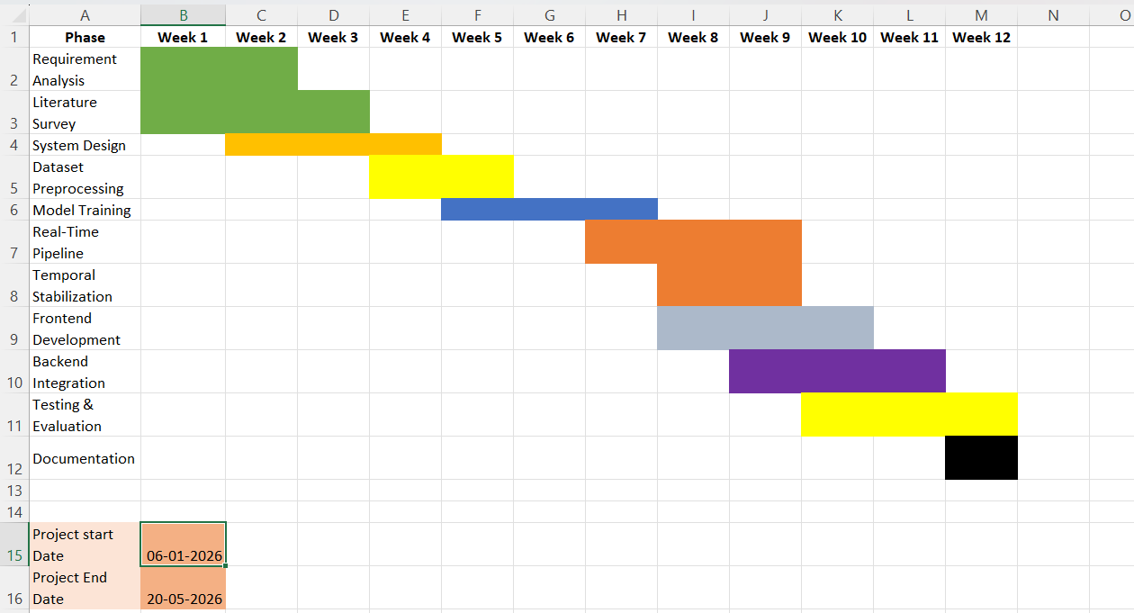
Fig 1. Gantt chart for Project Planning.

4.2 Risk Identification
Several technical and implementation-related risks were identified during the development of the project. One of the major challenges involved maintaining stable real-time emotion prediction during continuous webcam processing. Variations in lighting conditions, facial angles, webcam quality, and rapid facial movements often affected prediction consistency and reduced real-time reliability.
Another important challenge was the limitation of the FER-2013 dataset, which contains low-resolution grayscale images with subtle inter-class similarities between emotions such as fear, sadness, and neutral expressions. These limitations affected overall prediction accuracy and increased the possibility of emotion misclassification during real-time inference.
Frontend-backend synchronization and low-latency real-time processing also presented implementation challenges. Continuous webcam frame processing, API communication, and frontend dashboard updates required optimization to maintain smooth real-time interaction without significant delays.
To address these challenges, temporal stabilization techniques such as rolling emotion buffers, Rolling Probability Averaging, confidence filtering, and cooldown logic were implemented to reduce prediction flickering and improve output consistency. Continuous testing, debugging, and iterative refinement were also carried out throughout development to improve overall system stability and performance as shown in Table 5.
Table 5. Risk Identification and Mitigation
Risk Identified | Impact on Project | Mitigation Strategy
Unstable real-time emotion predictions | Inconsistent emotion output during webcam processing | Implemented temporal stabilization, Rolling Probability Averaging, and buffering techniques
Lighting and webcam quality variations | Reduced prediction accuracy | Applied preprocessing and face normalization techniques
FER-2013 dataset limitations | Difficulty in recognizing subtle emotions | Used transfer learning and augmentation techniques
Emotion misclassification | Incorrect emotion prediction for similar expressions | Implemented confidence filtering and stabilization logic
Frontend-backend synchronization issues | Delays in real-time dashboard updates | Optimized Flask API communication and UI rendering
Real-time processing latency | Reduced responsiveness during webcam inference | Optimized preprocessing and prediction pipeline
Prediction flickering | Frequent emotion switching across frames | Introduced cooldown logic and rolling emotion buffers
Limited computational resources | Slower training and inference performance | Used lightweight deployment configuration and optimized execution
Testing and debugging complexity | Unexpected runtime and integration issues | Conducted iterative testing and module-level validation
Incomplete personalization features | Limited adaptive learning capability | Defined baseline-aware calibration and future adaptive extensions

SOFTWARE REQUIREMENT SPECIFICATIONS

5.1 Functional Requirements

5.1.1 User Interface Module
The system provides a responsive web-based frontend interface developed using React, Vite, and Tailwind CSS. The user interface allows users to access real-time emotion detection features, view live webcam feed, monitor detected emotions, analyse confidence scores, and interact with dashboard components such as emotion cards, analytics pages, session timelines, and music recommendation sections.
The frontend also includes login and registration interface pages for user interaction and session management. Animated UI components and responsive layouts are implemented to improve usability and user experience across different screen sizes.

5.1.2 Emotion Detection Module
The emotion detection module performs real-time facial emotion recognition using OpenCV Haar Cascade face detection and a ConvNeXt-Tiny model trained on the FER-2013 dataset. The module continuously captures webcam frames, detects facial regions, preprocesses images, and predicts one of seven emotions: Angry, Disgust, Fear, Happy, Neutral, Sad, and Surprise.
The predicted emotion along with confidence scores is sent to the frontend dashboard through Flask APIs for real-time visualization and interaction.

5.1.3 Temporal Stabilization Module
The temporal stabilization module is implemented to reduce unstable emotion predictions and prediction flickering during continuous webcam processing. The module uses rolling emotion buffers, Rolling Probability Averaging, confidence filtering, and cooldown logic to stabilize predictions across multiple consecutive frames before updating the final displayed emotion.
This module improves prediction consistency and enhances the practical usability of the real-time emotion recognition system.

5.1.4 Music Recommendation Module
The system includes an emotion-aware music recommendation module that provides playlist suggestions based on the stabilized detected emotion. Rule-based mapping techniques are used to associate emotions with suitable music categories such as energetic, calm, relaxing, or focus-oriented playlists.
The module is integrated within the frontend dashboard and updates recommendations dynamically according to the detected emotional state.

5.1.5 Analytics and Session Tracking Module
The analytics module maintains temporary session-based emotional tracking and visualization features. The system displays emotion timelines, confidence analysis, session insights, and activity tracking components through the frontend dashboard.
This module helps users observe emotional trends and interaction history during continuous system usage.

5.1.6 Backend API Module
The backend module is implemented using Flask REST APIs for handling real-time prediction requests, emotion history retrieval, baseline data handling, analytics communication, and frontend-backend synchronization.
The backend manages communication between the webcam processing pipeline, Deep Learning model, temporal stabilization logic, and frontend dashboard interface.

5.2 Non-Functional Requirements

5.2.1 Performance Requirements
The system is designed to perform real-time facial emotion recognition with minimal latency during webcam processing. The prediction pipeline, frontend dashboard updates, and API communication are optimized to provide smooth interaction and continuous emotion visualization without significant delays.
Temporal stabilization mechanisms are implemented to improve prediction consistency and reduce rapid fluctuations during continuous frame processing.

5.2.2 Usability Requirements
The application provides a responsive and user-friendly interface developed using React and Tailwind CSS. The dashboard includes live webcam feed, emotion visualization, analytics components, confidence display, and emotion-aware music recommendation features to improve user interaction and accessibility.
The frontend layout is designed to support smooth navigation and real-time interaction across different screen sizes and display resolutions.

5.2.3 Reliability Requirements
The system is designed to maintain stable operation during continuous webcam-based emotion detection. Real-time prediction buffering, Rolling Probability Averaging, and cooldown logic help improve prediction reliability and reduce inconsistent emotion outputs caused by temporary facial movement or lighting variations.
Continuous testing and debugging were performed during development to improve overall system stability and runtime consistency.

5.2.4 Security Requirements
The current implementation includes frontend-based login and registration interfaces for user interaction. Basic session handling and local storage mechanisms are used for temporary user-related data management.
The project is primarily developed for academic and research purposes, and advanced authentication security, encrypted database systems, and cloud-based access control mechanisms are considered part of future enhancements.

5.2.5 Scalability Requirements
The modular architecture of the system allows future integration of advanced features such as LSTM-based temporal modelling, cloud deployment, database connectivity, multimodal emotion recognition, and adaptive learning systems without major architectural redesign.
The frontend-backend separation using Flask APIs also supports future scalability and independent module enhancement.

5.2.6 Software Quality Attributes
The system focuses on maintaining prediction stability, real-time responsiveness, usability, modularity, and frontend responsiveness. The use of transfer learning, temporal stabilization, and modular API-based architecture improves maintainability and future extensibility of the application.

5.2.7 Business Rules
The project is developed for educational and research-oriented purposes. User consent is required before enabling webcam-based emotion analysis. The system is intended for emotion recognition and interactive analysis only and is not designed for medical diagnosis or psychological evaluation.

DESIGN AND IMPLEMENTATION

6.1 Introduction
The proposed system is designed to perform real-time facial emotion recognition using Deep Learning and Computer Vision techniques. The implementation integrates webcam-based face detection, Deep Learning-based emotion classification, temporal stabilization mechanisms, frontend visualization, and emotion-aware interaction within a unified web-based platform.
The system uses Media Pipe for real-time face detection and a ConvNeXt-Tiny based deep learning model trained on the FER-2013 dataset for recognizing emotions such as Angry, Disgust, Fear, Happy, Neutral, Sad, and Surprise. Flask APIs are used for backend processing and communication, while the frontend interface is developed using React, Vite, and Tailwind CSS to provide responsive real-time interaction and visualization features.
The implementation also includes temporal stabilization techniques such as rolling emotion buffers, Rolling Probability Averaging, confidence filtering, and cooldown logic to reduce prediction flickering during continuous webcam processing. Additional frontend features such as analytics visualization, emotion timelines, confidence display, and emotion-aware music recommendation are integrated to improve usability and interactive experience.
The overall system is implemented using a modular architecture, allowing future integration of advanced features such as LSTM-based temporal learning, adaptive personalization, multimodal emotion analysis, and cloud-based deployment.

6.2 Architecture Design
The proposed system follows a modular client-server architecture designed for real-time facial emotion recognition and interactive emotion-aware visualization. The architecture consists of frontend components, backend APIs, webcam-based face processing modules, Deep Learning-based prediction models, temporal stabilization mechanisms, and emotion-aware interaction modules.
The system begins by capturing live webcam video frames from the user through the frontend interface. These frames are processed using Media Pipe for real-time face detection and facial region extraction. The detected face is then preprocessed by resizing, normalization, and RGB conversion before being passed to the ConvNeXt-Tiny based deep learning model for emotion prediction.
The Deep Learning model generates probability scores for seven emotions namely Angry, Disgust, Fear, Happy, Neutral, Sad, and Surprise. To improve prediction stability during continuous webcam processing, temporal stabilization mechanisms such as rolling emotion buffers, Rolling Probability Averaging, confidence filtering, and cooldown logic are applied before generating the final stable emotion output.

The stabilized emotion data is transmitted through Flask REST APIs to the React-based frontend dashboard, where live emotion visualization, confidence display, session analytics, timeline tracking, and emotion-aware music recommendation are presented to the user. The modular architecture also supports future integration of advanced temporal learning, adaptive personalization, cloud deployment, and multimodal emotion recognition features. The overall workflow and interaction between different modules of the proposed system are illustrated in Fig.2.
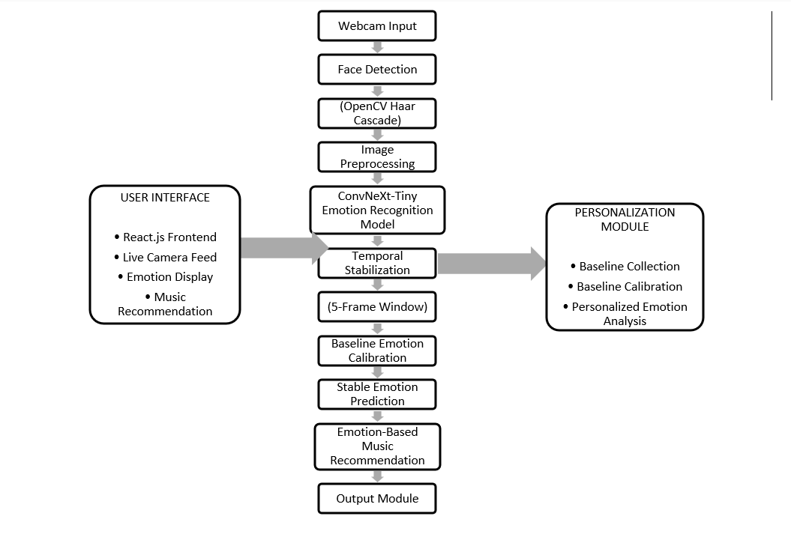
Fig 2. System Architecture.

1. Webcam Video Input
The proposed system begins by capturing live video frames from the user’s webcam through the frontend interface. The webcam continuously provides real-time facial video input to the backend processing pipeline for emotion analysis. Continuous frame acquisition enables the system to perform dynamic and real-time emotion recognition instead of static image-based prediction.
2. OpenCV Haar Cascade Face Detection
OpenCV is used for efficient real-time face detection and facial landmark identification from each webcam frame. The module accurately locates the facial region even under moderate head movement and lighting variation conditions. The detected face coordinates are then forwarded to the preprocessing stage for further analysis.

3. Face Preprocessing
The detected facial image undergoes several preprocessing operations before being passed to the Deep Learning model. These operations include facial cropping, resizing, normalization, RGB conversion, and pixel value scaling. Preprocessing helps improve model compatibility, reduces noise, and enhances prediction accuracy during real-time execution.
4. ConvNeXt Feature Extraction
The preprocessed facial image is passed to ConvNeXt-Tiny based deep learning model for deep feature extraction. The model extracts high-level facial features such as eye movement, mouth structure, eyebrow position, and expression patterns. Transfer learning using pretrained ImageNet weights improves feature learning efficiency and emotion classification performance.
5. Temporal Feature Buffer
The extracted facial features from consecutive webcam frames are temporarily stored in a rolling temporal buffer. This buffer maintains short-term emotional history and allows the system to analyse emotional transitions across multiple continuous frames instead of relying only on single-frame predictions.
6. Temporal Stabilization using Rolling Probability Averaging
The Temporal Stabilization processes sequential facial features stored within the temporal buffer. The model learns temporal emotional behaviour and identifies meaningful emotional patterns across continuous video frames. This helps improve prediction consistency and reduces unstable frame-by-frame emotion fluctuations.
7. Baseline Emotion Vector Generation
The system generates a personalized baseline emotion vector representing the user’s natural neutral facial behaviour. This baseline helps the system understand individual facial expression characteristics and reduces prediction bias caused by naturally expressive or non-expressive faces.
8. Relative Emotion Calibration
The detected emotional state is compared with the user’s baseline emotion profile to perform adaptive emotion calibration. Relative emotion interpretation improves personalization and enables more accurate emotion prediction by considering user-specific facial behaviour patterns instead of relying only on generalized dataset features.
9. Emotion Stability Filtering
To reduce unstable predictions and rapid emotion switching, the system applies temporal stabilization techniques such as rolling emotion buffering, Rolling Probability Averaging, confidence filtering, and cooldown logic. These methods smooth sudden fluctuations and generate more stable real-time emotion outputs.

10. Final Emotion Prediction
After temporal analysis and stabilization, the system generates the final predicted emotional state. The output emotion represents the most stable and reliable interpretation of the user’s current emotional condition based on spatial, temporal, and personalized emotional analysis.

6.3 Data Flow Diagram
The data flow of the proposed system begins with live webcam video input captured through the frontend interface. The captured frames are sent to the backend processing pipeline where Media Pipe performs real-time face detection and facial region extraction. The detected face is then pre-processed through resizing, normalization, and RGB conversion to make it compatible with the ConvNeXt-Tiny-based CNN model.
The pre-processed facial image is passed to the Deep Learning model, which predicts probability scores for the supported emotions namely Angry, Disgust, Fear, Happy, Neutral, Sad, and Surprise. The predicted emotion values are then processed by the temporal stabilization module, which applies rolling emotion buffering, Rolling Probability Averaging, confidence filtering, and cooldown logic to generate stable emotion outputs.
The stabilized emotion information is transmitted through Flask REST APIs to the React frontend dashboard. The frontend displays live emotion predictions, confidence visualization, analytics, emotion timelines, session tracking, and emotion-aware music recommendations. The system also stores temporary session-related emotional data for analytics and interaction purposes. The overall movement of data between different modules in the proposed system is illustrated in Fig. 3.

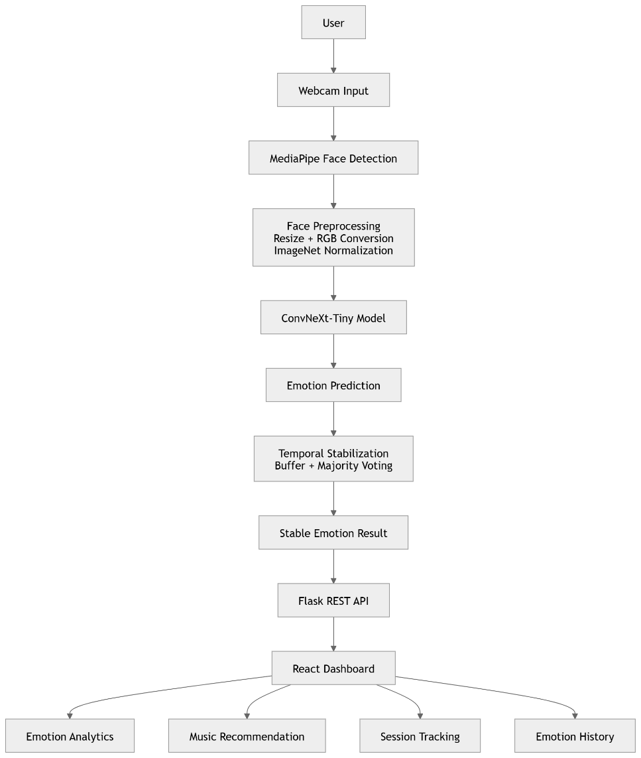

Fig 3. Data-Flow Diagram.

6.4 Tools and Technologies Used
The proposed system was developed using modern Deep Learning, Computer Vision, frontend development, and backend integration technologies to support real-time facial emotion recognition and interactive visualization. Python was used as the primary programming language for backend development, model integration, and real-time processing due to its extensive support for Artificial Intelligence and Machine Learning libraries.
TensorFlow and Keras were used for implementing and training the ConvNeXt-Tiny-based Convolutional Neural Network (CNN) model used for facial emotion classification. The FER-2013 dataset was utilized for training and evaluation of the model. OpenCV was used for image preprocessing, webcam frame handling, and real-time video processing, while Media Pipe was integrated for efficient real-time face detection and facial region extraction.
The backend services and API communication were implemented using Flask REST APIs to support real-time interaction between the prediction pipeline and frontend dashboard. The frontend interface was developed using React and Vite to provide a responsive and interactive user experience. Tailwind CSS was used for styling the dashboard components, analytics pages, emotion visualization cards, and responsive layouts.
Additional libraries such as NumPy and scikit-learn were used for numerical computation, preprocessing, evaluation metrics, and confusion matrix analysis. The complete system was developed and tested using Visual Studio Code on a Windows 11 environment.

6.5 Overall View of Project Implementation
The implementation of the proposed system begins with live webcam-based video capture through the frontend dashboard interface. The captured video frames are processed in real time using Media Pipe for face detection and facial region extraction. Once the face is detected, the facial image is cropped and pre-processed through resizing, normalization, and RGB conversion to make it compatible with the ConvNeXt-Tiny-based CNN model.
The pre-processed facial image is then passed to the trained Deep Learning model, which predicts probability scores for the supported emotions including Angry, Disgust, Fear, Happy, Neutral, Sad, and Surprise. The prediction results are processed using temporal stabilization mechanisms such as rolling emotion buffers, Rolling Probability Averaging, confidence filtering, and cooldown logic to reduce unstable predictions and prediction flickering during continuous webcam processing.
The stabilized emotion output is transmitted through Flask REST APIs to the React-based frontend dashboard. The frontend interface displays live emotion predictions, confidence visualization, session timelines, analytics components, and emotion-aware music recommendation features in real time. The dashboard also includes animated UI elements, responsive layouts, and temporary session-based emotional tracking for improved user interaction.
The system was developed using a modular architecture where the frontend, backend, prediction pipeline, and stabilization logic operate independently while communicating through APIs. This implementation approach improves maintainability, scalability, and future integration of advanced features such as LSTM-based temporal learning, adaptive personalization, multimodal emotion recognition, and cloud-based deployment.

6.6 Machine Learning Model Implementation
The proposed facial emotion recognition system was developed through a series of deep learning experiments using transfer learning architectures trained on the FER-2013 dataset. Multiple pretrained Convolutional Neural Network (CNN) models were evaluated to identify the architecture that provided the best balance between classification accuracy, generalization capability, and real-time deployment performance.
The FER-2013 dataset containing facial images representing seven emotions namely Angry, Disgust, Fear, Happy, Neutral, Sad, and Surprise was used for training and evaluation. The images were preprocessed through resizing, RGB conversion, normalization, and data augmentation techniques including horizontal flipping, rotation, affine transformation, and random cropping.
The implementation process involved evaluating multiple transfer learning architectures including Baseline ResNet50, ResNet50V2, Progressive Unfreezing ResNet50V2, EfficientNet-B0, and ConvNeXt-Tiny. Each model was trained and tested under similar conditions, and performance was compared using accuracy, precision, recall, F1-score, and confusion matrix analysis.
Among all evaluated architectures, ConvNeXt-Tiny achieved the highest overall performance and was therefore selected as the final deployment model for real-time emotion recognition. The model was subsequently integrated with the Flask backend, OpenCV face detection pipeline, temporal stabilization module, and React frontend dashboard.

6.6.1 Baseline ResNet50 Model
The initial experiment was conducted using the ResNet50 architecture with ImageNet pretrained weights. Transfer learning was applied by replacing the final classification layer with a seven-class emotion classifier corresponding to the FER-2013 emotion categories.
Although ResNet50 demonstrated effective feature extraction capabilities, the model suffered from underfitting and poor adaptation to facial emotion patterns within the FER-2013 dataset. The model achieved approximately 16.91% test accuracy, indicating limited suitability for practical real-time emotion recognition.
The experiment served as a baseline for evaluating improvements introduced by later architectures.

6.6.2 ResNet50V2 Model
To improve feature extraction and optimization performance, the ResNet50V2 architecture was implemented. The improved residual connections and pre-activation blocks enabled better gradient propagation and feature learning.
The model was trained using transfer learning and fine-tuning strategies. Data augmentation and class balancing techniques were also employed to improve generalization.
The ResNet50V2 model achieved a test accuracy of approximately 67.99%, representing a significant improvement over the baseline ResNet50 implementation.

6.6.3 Progressive Unfreezing ResNet50V2
A progressive unfreezing strategy was implemented to further improve performance. Initially, only the classification layers were trained while keeping the pretrained backbone frozen. Subsequently, deeper layers were gradually unfrozen and fine-tuned.
This approach enabled the network to adapt ImageNet features more effectively to facial emotion recognition while reducing overfitting.
The Progressive Unfreezing ResNet50V2 model achieved approximately 69.66% test accuracy and demonstrated improved stability across emotion classes compared to the standard ResNet50V2 model.

6.6.4 EfficientNet-B0 Model
EfficientNet-B0 was evaluated because of its balanced scaling strategy and lightweight architecture. The model provides improved parameter efficiency while maintaining competitive classification performance.
The network was trained using transfer learning, weighted loss functions, and data augmentation techniques. EfficientNet-B0 demonstrated good computational efficiency and lower resource requirements compared to deeper architectures.
Although the model achieved satisfactory performance, its overall accuracy remained lower than ConvNeXt-Tiny, and therefore it was not selected for final deployment.

6.6.5 ConvNeXt-Tiny Model (Final Model)
The final experiment utilized ConvNeXt-Tiny, a modern convolutional neural network architecture inspired by transformer design principles while retaining the efficiency of CNNs. The architecture incorporates large kernel convolutions, layer normalization, residual connections, and improved feature aggregation mechanisms.
The model was trained using ImageNet pretrained weights and optimized using the AdamW optimizer. Additional techniques such as weighted cross-entropy loss, dropout regularization, learning rate scheduling, mixed precision training, and extensive data augmentation were employed to improve generalization performance.
The ConvNeXt-Tiny model achieved the highest overall performance with approximately 74.2% test accuracy on the FER-2013 dataset. The architecture demonstrated superior feature extraction capability, improved robustness across different emotion classes, and stable real-time inference performance.
Due to its superior accuracy and generalization capability, ConvNeXt-Tiny was selected as the final emotion recognition model for integration into the proposed Emotion Companion system.

Mathematical Representation
The convolution operation used in CNN feature extraction can be represented as:
$$Feature Map=Input*Kernel+Bias$$
The Rectified Linear Unit (ReLU) activation function is defined as:
$$f(x)=max(0,x)$$
The Softmax function used for multiclass emotion classification is represented as:
$$P(y_{i})=\frac{e^{z_{i}}}{\sum_{j=1}^{n}{e^{z_{j}}}}$$
where $P(y_{i})$represents the probability of the $i^{th}$emotion class.

6.6.6 Temporal Stabilization
Real-time frame-by-frame emotion prediction often produces unstable outputs due to rapid facial movement, webcam noise, and temporary expression variations. To address this issue, temporal stabilization mechanisms were implemented within the prediction pipeline.
The system uses rolling emotion buffers, deque-based storage, Rolling Probability Averaging, confidence filtering, and cooldown logic to stabilize predictions across multiple consecutive frames before updating the final displayed emotion. A buffer size of approximately 15 frames was used to reduce prediction flickering and improve consistency during continuous webcam processing.
Mathematical Representation
The stabilized emotion can be represented as:
$$Stable Emotion=Mode(E_{1},E_{2},E_{3},...,E_{n})$$
where $E_{n}$represents predicted emotions across recent frames stored in the rolling buffer.

6.6.7 Baseline-Aware Emotion Analysis
The proposed system also explores baseline-aware emotional analysis concepts intended to improve personalization and reduce prediction bias caused by naturally expressive facial patterns. The idea behind baseline-aware analysis is to interpret future emotions relative to a user’s natural neutral facial behaviour rather than relying entirely on generalized dataset-based predictions.
In the current implementation, baseline-aware calibration concepts and related API structures are partially integrated within the system design. Future extensions may further enhance this approach through adaptive learning, user-specific emotional modelling, and sequence-based temporal learning techniques.

6.7 Information About Implementation of Modules
The proposed system is implemented using multiple interconnected modules that collectively perform real-time facial emotion recognition, prediction stabilization, frontend visualization, and emotion-aware interaction. Each module was independently developed and integrated into the complete system architecture to ensure modularity, maintainability, and real-time performance.

6.7.1 Frontend User Interface Module
The frontend module was developed using React, Vite, and Tailwind CSS to provide a responsive and interactive user interface for real-time emotion analysis. The dashboard displays live webcam feed, detected emotions, confidence visualization, emotion analytics, session timelines, activity tracking, and emotion-aware music recommendation components.
Animated UI elements and responsive layouts were implemented to improve usability and user interaction across different display sizes. Login and registration interface pages were also designed for basic session handling and user interaction workflows

6.7.2 Webcam Input and Face Detection Module
The webcam input module is responsible for capturing real-time video frames from the user’s webcam through the frontend interface. OpenCV Haar Cascade was integrated for efficient real-time face detection and facial landmark processing.
The detected facial region is extracted from each frame and forwarded to the preprocessing pipeline for further emotion analysis. The module was optimized to support continuous webcam processing with minimal latency during real-time interaction.

6.7.3 Image Preprocessing Module
The preprocessing module performs resizing, normalization, RGB conversion, and facial image preparation before passing the input to the ConvNeXt-Tiny-based CNN model. Since the FER-2013 dataset originally contains grayscale images of size 48×48, preprocessing operations were necessary to adapt the images for the pretrained ConvNeXt-Tiny architecture requiring RGB input of size 224×224×3.
Data augmentation techniques including horizontal flipping, rotation, width shifting, height shifting, and zoom transformations were also applied during model training to improve generalization and reduce overfitting.

6.7.4 Emotion Prediction Module
The emotion prediction module uses a ConvNeXt-Tiny-based Convolutional Neural Network trained on the FER-2013 dataset for classifying facial emotions. The model predicts probability scores for seven emotions namely Angry, Disgust, Fear, Happy, Neutral, Sad, and Surprise.
The prediction pipeline was integrated with Flask APIs to support continuous real-time emotion inference during webcam processing. Confidence scores generated by the model are also transmitted to the frontend dashboard for visualization and analytics.

6.7.5 Temporal Stabilization Module
The temporal stabilization module was implemented to reduce prediction flickering and unstable frame-by-frame emotion changes during continuous webcam analysis. The module uses rolling emotion buffers, deque-based storage, Rolling Probability Averaging, confidence filtering, and cooldown logic to stabilize emotion outputs across multiple consecutive frames.
A rolling buffer size of approximately 15 frames was used to improve prediction consistency and reduce sudden rapid changes in displayed emotions.

6.7.6 Music Recommendation Module
The music recommendation module provides emotion-aware playlist suggestions based on the stabilized detected emotion. Rule-based mapping logic was implemented to associate emotions with suitable music categories such as energetic, calm, relaxing, or focus-oriented playlists.
The recommendation system is integrated into the frontend dashboard and dynamically updates recommendations according to the currently detected stable emotion.

7.Results and Discussion

7.1 Experimental Setup
The proposed system was implemented and tested in a real-time environment using a webcam-enabled system under standard indoor lighting conditions. The frontend interface was developed using React, Vite, and Tailwind CSS, while Flask was used for backend API integration and real-time communication. OpenCV Haar Cascade was used for face detection and facial region extraction, and TensorFlow/Keras was used for implementing the ConvNeXt-Tiny-based CNN emotion recognition model.
The FER-2013 dataset was used for model training and evaluation. The dataset images were preprocessed through RGB conversion, resizing, normalization, and augmentation before training. The trained model was integrated into a real-time webcam prediction pipeline for continuous facial emotion recognition.
The system was tested for recognizing emotions such as Angry, Disgust, Fear, Happy, Neutral, Sad, and Surprise during continuous webcam interaction. Additional modules such as temporal stabilization, confidence filtering, frontend analytics visualization, and emotion-aware music recommendation were also evaluated during real-time execution.

7.2 Evaluation Metrics
The performance of the facial emotion recognition models was evaluated using multiple classification metrics to obtain a comprehensive assessment of prediction quality. The evaluation was performed on the FER-2013 test dataset containing seven emotion classes: Angry, Disgust, Fear, Happy, Neutral, Sad, and Surprise.
1. Accuracy
Accuracy measures the overall proportion of correctly classified samples among all test samples.
Accuracy = (TP + TN) / (TP + TN + FP + FN)
where:
TP = True Positives
TN = True Negatives
FP = False Positives
FN = False Negatives
A higher accuracy value indicates better overall classification performance.
2. Precision
Precision measures the proportion of correctly predicted samples among all samples predicted for a particular emotion class.
Precision = TP / (TP + FP)
High precision indicates that the model produces fewer false positive predictions.
3. Recall
Recall measures the ability of the model to correctly identify samples belonging to a particular emotion class.
Recall = TP / (TP + FN)
A high recall value indicates effective detection of emotion samples belonging to that class.
4. F1-Score
The F1-Score provides a balanced measure of precision and recall.
F1-Score = 2 × (Precision × Recall) / (Precision + Recall)
The metric is particularly useful when class distributions are imbalanced.
5. Confusion Matrix
A confusion matrix was generated for each model to visualize classification performance across all seven emotion classes. The matrix compares actual class labels with predicted class labels and helps identify frequently confused emotions. Diagonal elements represent correctly classified samples, while off-diagonal elements indicate misclassifications.
6. Classification Report
A detailed classification report was generated for each evaluated model. The report provides class-wise Precision, Recall, F1-Score, and Support values, enabling a deeper analysis of model performance for individual emotion categories.
7. Comparative Model Evaluation
Multiple deep learning architectures including Baseline ResNet50, ResNet50V2, Progressive Unfreezing ResNet50V2, EfficientNet-B0, and ConvNeXt-Tiny were evaluated using the above metrics. Comparative analysis was performed to identify the model providing the best balance between classification accuracy, robustness, and real-time deployment suitability.

Table 6. Comparative Performance Analysis of Evaluated Deep Learning Models on the FER-2013 Dataset
Model | Accuracy (%)
Baseline ResNet50 | 65.03
ResNet50V2 | 67.99
Progressive Unfreezing ResNet50V2 | 69.66
EfficientNet-B0 | 71.8
ConvNeXt-Tiny | 74.20

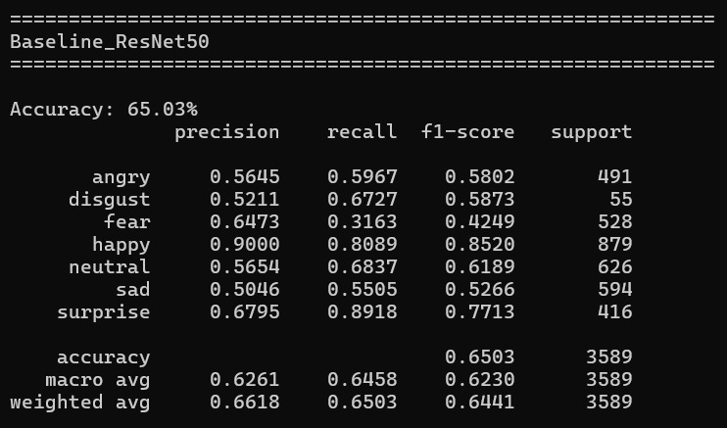
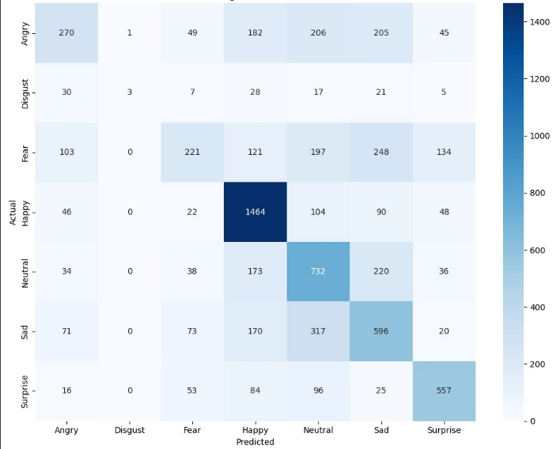
Baseline ResNet50 Model

Fig 4. ResNet50 Confusion Matrix. Fig 5. ResNet50 Classification Report.

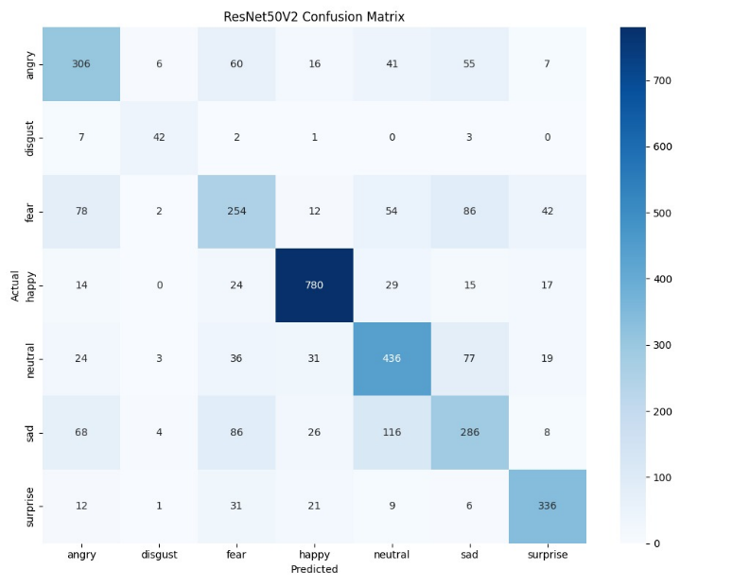
ResNet50V2 Model
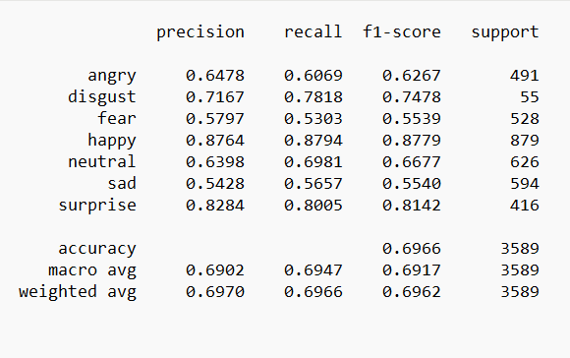

Fig 6. ResNet50V2 Confusion Matrix Fig 7. ResNet50V2 Classification Report.

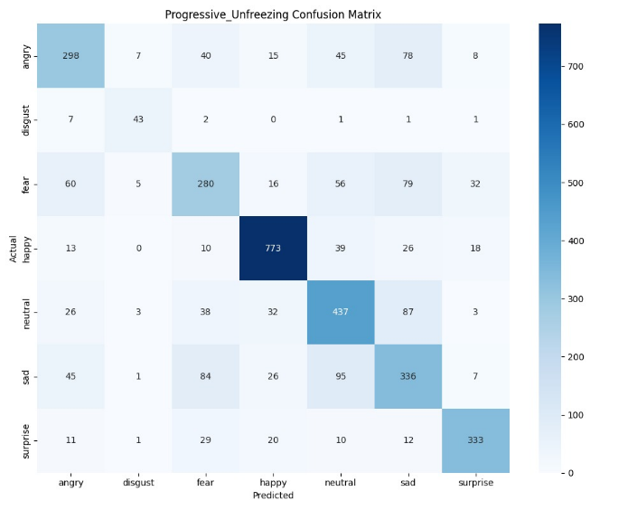
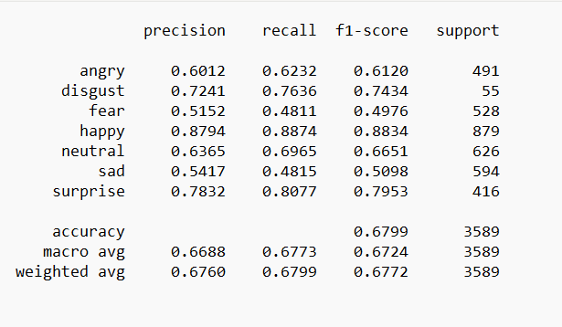
Progressive Unfreezing ResNet50V2

Fig 8. Progressive ResNet50V2 Confusion Matrix. Fig 9. Progressive ResNet50V2 Report.

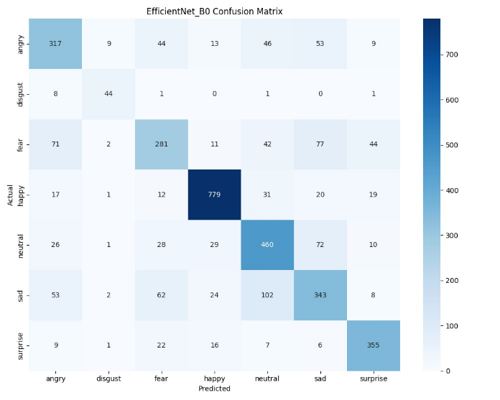
EfficientNet-B0 Model
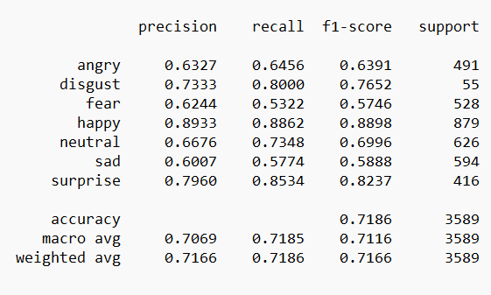

Fig 10. EfficientNet-B0 Confusion Matrix Fig 11. EfficientNet-B0 Classification Report

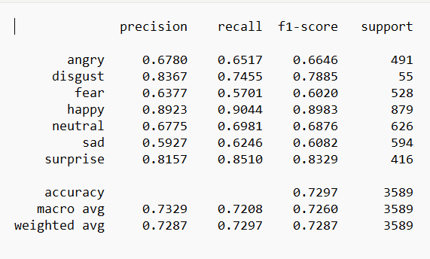
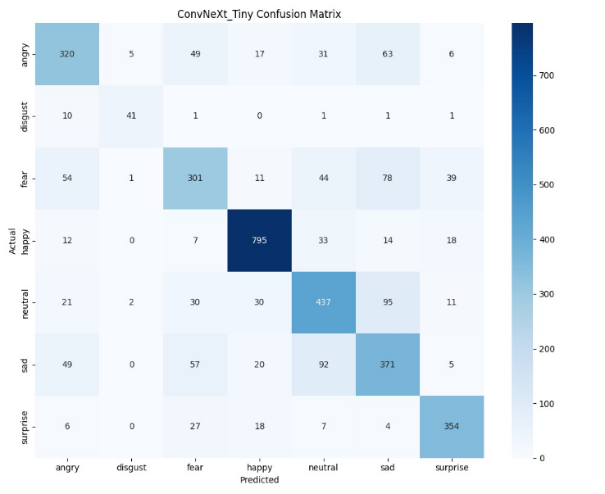
ConvNeXt-Tiny Model

Fig 12. ConvNeXt model Confusion Matrix Fig 13. ConvNeXt model Classification Report

7.3 Results
The implemented system successfully performed real-time facial emotion recognition using webcam input and Deep Learning techniques. The ConvNeXt-Tiny-based CNN model achieved approximately 74.2% test accuracy and 98% training accuracy on the FER-2013 dataset, which is considered reasonable for real-time FER systems due to low-resolution images, subtle emotion overlap, and dataset imbalance.
The model was capable of recognizing emotions such as Angry, Disgust, Fear, Happy, Neutral, Sad, and Surprise during continuous webcam interaction. Real-time prediction results were displayed successfully through the React-based frontend dashboard along with confidence visualization, session analytics, and emotion-aware music recommendation features, as shown in Fig. 6.
The temporal stabilization module significantly reduced prediction flickering during continuous webcam processing. Rolling emotion buffers, Rolling Probability Averaging, confidence filtering, and cooldown logic improved prediction consistency across consecutive frames and enhanced overall user experience. The profile management and session handling interface developed for the proposed system is illustrated in Fig. 7.
The frontend and backend integration functioned smoothly during real-time execution, enabling responsive webcam processing, low-latency API communication, and continuous dashboard updates. The activity tracking and emotion history visualization module implemented within the dashboard is shown in Fig. 8.
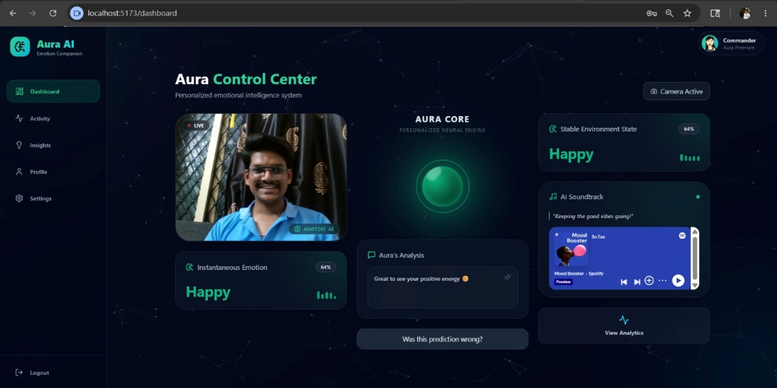
Fig 14. Dashboard.
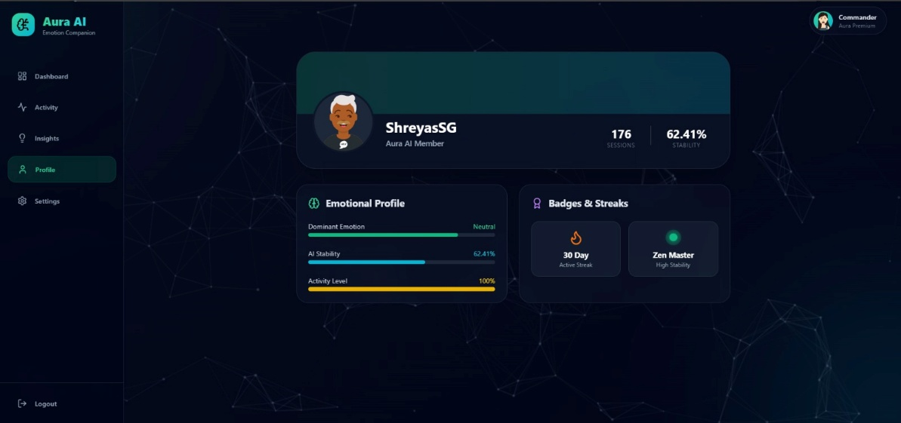
Fig 15. Profile Section.
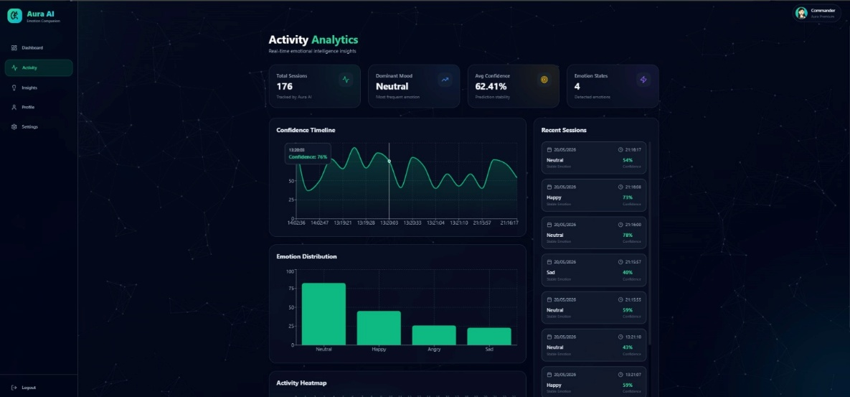
Fig 16. Activity Section.

7.4 Discussion
The experimental results demonstrate that Deep Learning and transfer learning techniques can effectively perform real-time facial emotion recognition using webcam input and lightweight deployment environments. The integration of temporal stabilization mechanisms significantly improved prediction stability and reduced unstable frame-by-frame emotion fluctuations.
Although the system achieved stable real-time performance, certain limitations were observed during testing. Emotions such as Fear, Disgust, and Neutral occasionally showed inter-class similarity, leading to misclassification under challenging lighting conditions or rapid facial movement. The low-resolution nature of the FER-2013 dataset also affected subtle facial feature representation during prediction.

8. TESTING

8.1 Introduction
Testing is an important phase in the development of the proposed facial emotion recognition system to ensure proper functionality, prediction consistency, frontend responsiveness, and real-time performance. Different modules of the system including webcam input, face detection, emotion prediction, temporal stabilization, frontend-backend communication, and dashboard visualization were tested individually as well as after complete system integration.
The testing process helped identify issues related to unstable predictions, prediction flickering, latency during webcam processing, frontend synchronization delays, and emotion misclassification under varying lighting conditions. Continuous debugging and iterative refinement were performed throughout development to improve prediction stability, responsiveness, and overall system reliability.
Both functional and performance-based testing approaches were used to evaluate the real-time behaviour of the system under continuous webcam interaction.

8.2 Testing Tools and Environment
The proposed system was tested using a Windows 11 environment with webcam support under standard indoor lighting conditions. The frontend interface was executed using React and Vite development servers, while Flask was used for backend API testing and real-time communication validation.
TensorFlow/Keras was used to verify Deep Learning model predictions, and OpenCV Haar Cascade along with OpenCV was used for testing real-time face detection and preprocessing pipelines. Additional evaluation metrics such as Accuracy, Precision, Recall, F1-Score, and Confusion Matrix analysis were implemented using scikit-learn libraries.
The complete system was developed and tested using Visual Studio Code with CPU-based execution during real-time deployment and other components as shown in Table 6.
Table 7. Testing Environment
Component | Details
Operating System | Windows 10/11
Programming Language | Python, JavaScript
Frontend Framework | React.js
Backend Framework | Flask
Deep Learning Library | PyTorch / TorchVision
Image Processing Tool | OpenCV
Development Tool | VS Code
Hardware | Laptop with Webcam

8.3 Test Cases
Table 8. Test Cases
Test Case ID | Test Scenario | Test Steps | Expected Result | Actual Result | Status
TC01 | User Login Validation | - Open Application  - Enter valid credentials and click Login | User should login successfully | Login successful | Passed
TC02 | Webcam Initialization | - Click on ‘Start Detection’  - Allow webcam access | Webcam should start without errors | Webcam started successfully | Passed
TC03 | Face Detection | - Ensure face is visible in camera  - System detects the face | Face should be detected and marked | Face detected successfully | Passed
TC04 | Emotion Prediction | - Start real-time detection  - System predicts emotion | Emotion should be predicted with probability | Emotion predicted correctly | Passed
TC05 | Stable Emotion Detection (Temporal Smoothing) | - Move face with different expressions  - Check stable emotion output | Stable emotion should be displayed (less fluctuation) | Stable emotion displayed correctly | Passed
TC06 | Baseline Calibration | - Capture neutral expression for baseline | Baseline should be captured and stored | Baseline captured successfully | Passed
TC07 | Frontend-Backend Communication | - Trigger emotion detection  - Check API request and response | Data should be sent and received successfully | Data transmitted successfully | Passed
TC08 | Real-time Prediction | - Start live detection  - Check emotion displayed on UI | Predicted emotion should be updated in real time | Emotion updated in UI | Passed
TC09 | Personalized Feedback Processing | - Provide like/dislike feedback  - Check feedback stored | Feedback should be saved and linked to user | Feedback saved successfully | Passed
TC10 | System Response Under Lighting Variation | - Test under low light / high light  - Check prediction accuracy | System should work with acceptable accuracy | System performed with acceptable accuracy | Passed

9.CONCLUSION AND SCOPE FOR FUTURE WORK
The proposed project, “Emotion Companion: Baseline-Aware Temporal Facial Emotion Recognition System,” successfully demonstrates a real-time facial emotion recognition framework using Deep Learning and Computer Vision techniques. The system integrates MediaPipe-based face detection, a ConvNeXt-Tiny-based CNN emotion classification model, temporal stabilization mechanisms, and a responsive React-based frontend dashboard for continuous emotion-aware interaction.
The implemented system was capable of recognizing emotions such as Angry, Disgust, Fear, Happy, Neutral, Sad, and Surprise using webcam input in real time. Temporal stabilization techniques including rolling emotion buffers, Rolling Probability Averaging, confidence filtering, and cooldown logic significantly improved prediction consistency and reduced unstable frame-by-frame emotion fluctuations during continuous webcam processing.
The integration of frontend analytics, emotion timelines, confidence visualization, and emotion-aware music recommendation features enhanced overall user interaction and practical usability of the system. The modular architecture adopted during development also supports future scalability and integration of advanced adaptive learning techniques.
Although the system achieved stable real-time performance, certain limitations were observed due to low-resolution FER-2013 dataset images, inter-class emotion similarity, lighting sensitivity, and lack of advanced temporal sequence learning. Nevertheless, the project successfully demonstrates the practical implementation of emotionally aware intelligent systems using transfer learning, real-time processing, and interactive visualization techniques.

9.1 Scope for Future Work
The proposed system can be further enhanced by integrating advanced temporal learning and adaptive Artificial Intelligence techniques for improved personalization and long-term emotional analysis. Future versions may incorporate Long Short-Term Memory (LSTM) networks and sequence-based temporal modelling to better understand emotional transitions across continuous video frames.
The project may also be extended by implementing adaptive learning systems capable of improving prediction accuracy based on long-term user interaction and feedback. Cloud-based database integration and secure authentication systems can further support persistent user profiles, emotional history tracking, and scalable deployment.
Additional enhancements may include multimodal emotion recognition using voice analysis, speech tone, and textual sentiment analysis alongside facial expressions for more robust emotional understanding. Deployment as a mobile or cloud-based application can further improve accessibility and practical real-world usability.
Future improvements can also focus on increasing prediction accuracy under varying environmental conditions, reducing inference latency, implementing personalized recommendation learning, and integrating advanced conversational AI systems for more intelligent and emotionally aware human-computer interaction.

10. REFERENCES
[1] A. Mollahosseini, D. Chan, and M. H. Mahoor, “Going deeper in facial expression recognition using deep neural networks,” IEEE Winter Conference on Applications of Computer Vision (WACV), pp. 1–10, 2019.
[2] Y. Khaireddin and Z. Chen, “Facial emotion recognition: State of the art performance on FER2013,” arXiv preprint arXiv:2105.03588, 2021.
[3] S. Minaee, M. Minaei, and A. Abdolrashidi, “Deep-emotion: Facial expression recognition using attentional convolutional network,” Sensors, vol. 21, no. 9, pp. 1–18, 2021.
[4] S. Li and W. Deng, “Deep facial expression recognition: A survey,” IEEE Transactions on Affective Computing, vol. 13, no. 3, pp. 1195–1215, 2022.
[5] F. Wang, S. Xiang, and J. Pan, “Multimodal emotion recognition using deep learning techniques,” International Journal of Computer Vision and Signal Processing, vol. 14, no. 2, pp. 45–57, 2022.
[6] J. Zeng, Y. Hu, and K. Zhao, “Transformer-based facial emotion recognition framework,” IEEE Access, vol. 11, pp. 34567–34578, 2023.
[7] Z. Fu, H. Liu, and P. Wang, “Hybrid CNN-RNN model for real-time facial emotion analysis,” Journal of Artificial Intelligence Research, vol. 18, no. 4, pp. 221–233, 2023.
[8] G. Sonkavde, R. Mahajan, and S. Patil, “Artificial intelligence techniques for human emotion and behavior analysis,” International Journal of Advanced Computer Science and Applications, vol. 14, no. 1, pp. 112–121, 2023.
[9] A. Sharma, P. Verma, and R. Gupta, “Lightweight CNN model for real-time emotion recognition,” Procedia Computer Science, vol. 225, pp. 105–114, 2024.
[10] H. Kim and S. Lee, “Graph neural networks for facial emotion recognition,” IEEE Access, vol. 12, pp. 55210–55222, 2024.
[11] R. Ahmed, T. Khan, and S. Ali, “Personalized baseline calibration for adaptive emotion recognition,” Journal of Machine Learning Applications, vol. 9, no. 2, pp. 88–97, 2025.
[12] X. Chen, L. Zhang, and Y. Zhou, “Multimodal affective computing framework for intelligent human interaction,” IEEE Transactions on Multimedia, vol. 27, pp. 145–158, 2025.

